School Counseling Program Newsletter
Shandrai Silva, School Counselor | November 2016

Counselor Message  Happy November! It’s hard to believe the Thanksgiving holiday is near. We’re thankful for all the great things happening at Hawks Nest!  October was a busy month for Hawks Nest STEAM Academy and the school counseling program. In October, we recognized National Bullying Prevention Month and Red Ribbon Week. On Unity Day, we wore orange to show our commitment to ending bullying everywhere. Students participated in bullying prevention lessons during guidance classes and signed our Unity Day banner. During Red Ribbon Week, we participated in spirit week, learned about healthy living during the morning announcements and in classroom guidance. Congratulations to our Red Ribbon Week Door Decorating contest winners, Ms. Patz and Mrs. Branton (K-2) and Ms. Minnich (3-5).  November is going to be another  amazing month at the Nest- stay tuned!  __________________________  How to see the school counselor  Classroom guidance classes are weekly based on grade level specials schedule. Small group counseling and individual counseling by self -referral, parent referral, teacher referral, administrator referral or counselor initiated.  Contact School Counselor at 704-866-8467or sosilva@gaston.k12.nc.us. | Home of the Hawks  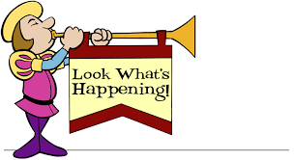  GCS Military Support Day  Wear Red, White and/or Blue on Wednesday, November 9th to show support for our military.    Nationwide Crenshaw Food Drive  November 7- 22, 2016  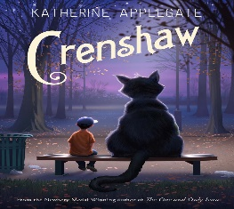  Help Feed Families in Need  Canned food items being collected  during the weeks leading up to Thanksgiving. #CrenshawFoodDrive | Character Education  “We’re Soaring with Good Character”  ______________________________  The character trait of the month is Respect. Respect is showing high regard for self, others and property. Students will have an opportunity to learn more about respect through morning announcements and classroom activities.  _______________________________________________  Promoting Character Education  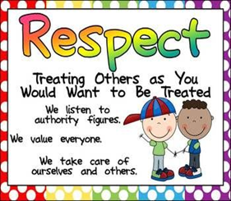  One can shows respect by…  1. Use kind words and good manners.  2. Listen to what others have to say.  3. Follow the rules.  4. Appreciate differences.  5. Take care of other people’s property at school, home, and in the community.  6. Help others.  “Intelligence plus character- that is the goal of true education.”  Dr. Martin L. King, Jr.

